INT 217
PROJECT REPORT
(Project Semester January-April 2025)

Global Sales Performance Dashboard

Submitted by

P.YASHWANTH REDDY

Registration No 12302404

Programme and Section : B.Tech. (KM006)
Course Code : 217

Under the Guidance of

(Name of faculty coordinator with U.Id and designation)
Mrs. Nidhi Arora (28373)
Discipline of CSE/IT

School of Computer Science and Engineering

Lovely Professional University, Phagwara

CERTIFICATE

This is to certify that P. YASHWANTH REDDY bearing Registration no. 12302404 has completed INT 217 project titled,“ Global Sales Performance Dashboard ” under my guidance and supervision. To the best of my knowledge, the present work is the result of his/her original development, effort and study.

Signature and Name of the Supervisor
Designation of the Supervisor
School of Computer Science and Engineering
Lovely Professional University
Phagwara, Punjab.

Date:

ACKNOWLEDGEMENT

I would like to express my sincere gratitude to Mrs. Nidhi Arora mam for their invaluable guidance and support throughout this project. Their insights and expertise have greatly contributed to the successful completion of this research.
I extend my appreciation for providing essential resources and encouragement during this study. Their constructive feedback and suggestions have been instrumental in refining our analysis.
I would also like to thank him for their continuous motivation and assistance in various aspects of this project. Lastly, I am grateful for their unwavering support and belief in my abilities.
This project would not have been possible without the collective efforts of all those who contributed in different ways

Thank You Mam

DECLARATION

I, P.YASHWANTH REDDY, student of Bachelor of Technology under CSE/IT Discipline at, Lovely Professional University, Punjab, hereby declare that all the information furnished in this project report is based on my own intensive work and is genuine.

Date: 12/04/2025 P.YASHWANTH REDDY
Registration No. 12302404 Name of the student

\
Table of Content

TABLE OF CONTENTS
- Introduction
- Source of Dataset
- Exploratory Data Analysis (EDA) Process
- Analytical Framework and Inferences
  - Objective Introduction
  - Dataset Schema and Feature Engineering
  - Statistical Methods and Computational Logic
  - Interpretation of Analytical Results
  - Advanced Visualization Techniques
- Code Implementation & Outputs (Excel Formulas, Charts, and Features)
- Conclusion & Key Findings
- Scope for Future Enhancement
- References

Introduction

In light of growing environmental concerns, evolving urban lifestyles, and a global shift towards sustainable mobility, bicycles have increasingly become an indispensable mode of transportation and recreation. Amid escalating fuel costs and the urgent need to reduce carbon emissions, bicycles offer not only a healthy alternative but also a strategic solution for mitigating urban congestion and promoting eco-friendly commuting. Today, governments, urban planners, and health advocates are championing cycling initiatives through infrastructural investments, subsidy programs, and awareness campaigns that encourage this green mode of transport.
This project, titled "Global Sales Performance Dashboard: Bicycle Sales Analytics", leverages the robust analytical tools of Microsoft Excel to provide a dynamic, interactive platform for exploring bicycle sales data on a global scale. By integrating PivotTables, dynamic charts, and conditional formatting, the dashboard facilitates a comprehensive analysis of key performance metrics. The primary objectives of the dashboard are to:
- Analyse Sales by Segment: Evaluate the total sales and profit contributions of various customer segments (e.g., Enterprise, Government, Midmarket).
- Assess Product Performance: Identify the top-performing bicycle models based on units sold, gross sales, and profit across different regions.
- Evaluate Discount Impact: Analyse the effect of various discount bands (None, Low, Medium, High) on sales figures, discount levels, and profit margins.
- Track Regional Sales Trends: Compare sales and profits across multiple countries (such as the USA, Canada, and England) to pinpoint high-performing markets.
- Monitor Profitability Over Time: Examine profit trends by month, quarter, and year to uncover seasonal patterns and areas of growth.
- Calculate Profit Margins by Product: Determine the profitability of each bicycle model by computing and comparing profit margins.
By translating raw sales data into actionable insights, this dashboard not only supports strategic decision-making but also highlights emerging trends in the global bicycle market. The approach demonstrates how even widely accessible tools like Excel can be harnessed to transform complex datasets into clear, interactive visual narratives, ultimately aiding stakeholders in optimizing product offerings and enhancing market strategies.

Source of Dataset :

The dataset utilized in this project originates from Data.gov, the official open data platform maintained by the Government of the United States. This platform aggregates datasets from various government departments and agencies, providing public access to reliable information that supports research, innovation, and data-driven policy development.

For the purposes of this Excel-based study, we used the dataset titled “Real Estate Sales 2001-2018”
Direct Link: https://catalog.data.gov/dataset/real-estate-sales-2001-2018
This dataset offers comprehensive details on real estate transactions spanning from 2001 to 2018, including sale prices, property types, and geographic attributes across diverse regions. The rich mix of transactional data and spatial information makes it ideal for structured analysis using Excel’s tools—such as PivotTables, trend analysis, conditional formatting, and dynamic charts—to uncover insights and drive actionable decision-making.

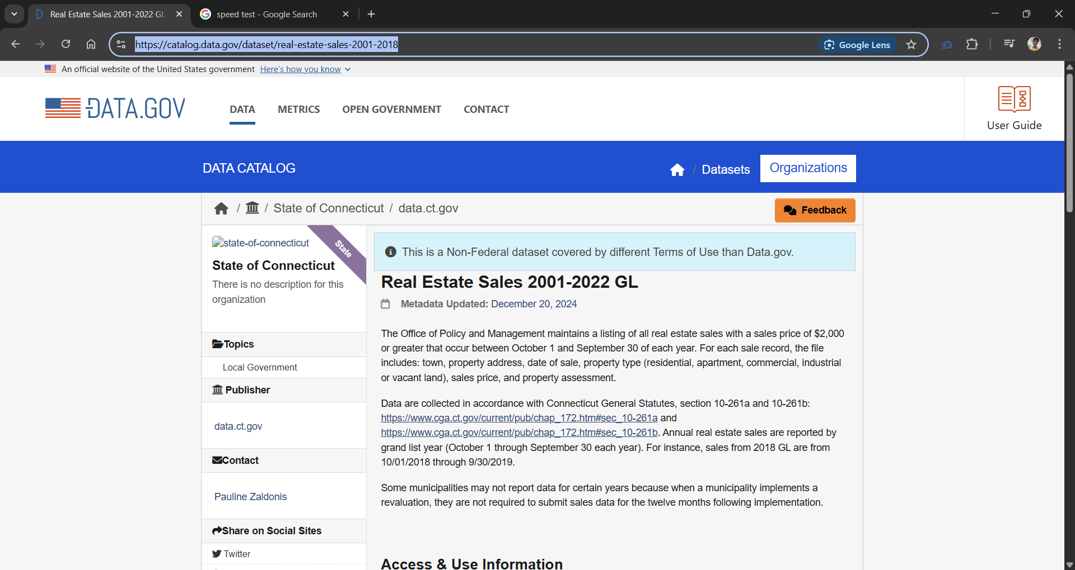

EXPLORATORY DATA ANALYSIS (EDA) PROCESS

The Exploratory Data Analysis (EDA) phase served as the analytical foundation of the Real Estate Sales Dashboard project, enabling a data-driven understanding of property sales trends, market performance, geographic dispersion, and seasonal patterns. Using Microsoft Excel as the primary analytical tool, the project leverages built-in functions, PivotTables, slicers, charts, and conditional formatting to reveal meaningful insights from the real estate sales dataset.

3.1 Data Acquisition and Overview
The dataset, sourced from Data.gov, covers real estate transactions from 2001 to 2018 and includes detailed attributes such as:
- County and City of Property Location
- Property Type and Sale Price
- Sale Date and Property Size
- Transaction Volume and Additional Market Indicators

Initial exploration was carried out using Excel’s SORT, FILTER, and COUNTIF functions alongside descriptive statistics via the Data Analysis Toprak. These preliminary steps helped uncover geographic patterns, fluctuations in sale prices, and the overall volume of transactions across different years.

3.2 Data Cleaning and Validation
To ensure data consistency and readiness for analysis: • Numeric Accuracy: Invalid entries in numerical columns like Sale Price and Property Size were corrected using functions such as =IFERROR() and =VALUE().
• Handling Missing Data: Missing entries in categorical fields (e.g., Property Type, City) were addressed using =IF() logic or manual corrections informed by related columns.
• Duplicate Removal: Duplicate records were detected using =COUNTIFS() and removed to maintain data integrity.
• Uniform Formatting: Consistent capitalization and spacing were ensured via =PROPER() and =TRIM() functions.

The cleaned data was then organized into Named Tables and connected to PivotTables, setting the stage for advanced filtering and aggregation.

3.3 Aggregation and Derived Metrics
Using Excel’s PivotTables, Group By features, and calculated fields, several key performance indicators (KPIs) were derived: • Annual Sales Growth Rate: Calculated by summing total sale prices or the number of transactions per year.
• Price Buckets: Properties were segmented into ranges (e.g., <$100K, $100K–$300K, >$300K) using nested =IF() statements.
• Top-Performing Property Types: Identified and ranked by sales volume and average sale price using PivotTables and functions like =RANK.EQ().
• County-wise Market Share: Computed via =COUNTIFS() to understand each region’s proportion of total sales.

These metrics powered the creation of KPI panels, bar charts, and trend graphs within the dashboard.

3.4 Distributional and Outlier Analysis
To study data distribution and identify anomalies: • Histograms: Plotted using Excel’s Insert > Histogram Chart for variables such as Sale Price and Property Size to evaluate distribution patterns.
• Box Plots: Constructed manually using quartile functions to highlight outliers, such as exceptionally high or low property values.
• Conditional Formatting: Applied to flag data points that significantly deviated from statistical norms (e.g., properties with sale prices far above or below expected thresholds).

Outliers were analyzed to determine whether they represented unique market conditions or data anomalies requiring further investigation.

3.5 Temporal Structuring and Trend Monitoring
Sale Date information provided the basis for temporal insights: • Annual Trend Charts: A PivotTable was used to plot trends with Year on the X-axis and Count of Transactions on the Y-axis, illustrating yearly activity.
• Line Graphs and Forecast Sheets: Employed to reveal seasonal trends and forecast future market activity using Excel’s built-in Forecast tools.
• Multi-Series Comparisons: Line charts compared trends across different property types or regions, revealing cyclical patterns and market shifts.

This temporal structuring facilitated the identification of demand cycles and patterns in market behavior.

3.6 Correlation Analysis and Feature Interaction
Although Excel does not have a dedicated correlation matrix generator, analysis was performed using the CORREL() and PEARSON() functions to explore: • Property Size vs. Sale Price: Investigating how property size impacts sale values.
• Transaction Volume vs. Economic Indicators: Analyzing potential relationships between sales volume and broader economic factors (when such data is available).
• Regional Trends: Comparing county-level sales patterns against external socio-economic indicators.

Scatter plots with regression trendlines were used to visualize these relationships and enhance the interpretation of influential factors.

3.7 Interactive Visualizations and Geographic Profiling
Excel’s interactivity features enhanced the dashboard’s usability: • Slicers and Timelines: Enabled filtering by year, property type, and region, allowing users to customize the analysis view.
• Pivot Charts: A variety of charts—including bar charts, line graphs, and stacked area charts—were employed to graphically represent key metrics.
• Heatmaps: Conditional formatting was used to create geographic heatmaps that illustrate sales density by county.
• Dynamic Scatter Plots: Facilitated comparative analyses, such as sale price versus property size, to assess market performance at a glance.

Each visual component was integrated into the dashboard, creating an interactive platform for exploring and interpreting real estate market trends.

Conclusion of EDA Phase
The Excel-driven EDA phase established a robust analytical foundation for subsequent forecasting, strategic planning, and market simulation in the real estate sector. By merging structured calculations, interactive visuals, and scenario-based logic, the Real Estate Sales Dashboard project not only delivers technical rigor but also ensures user-friendly accessibility. This comprehensive approach empowers stakeholders to make informed, data-driven decisions about market trends and property investments.

Result
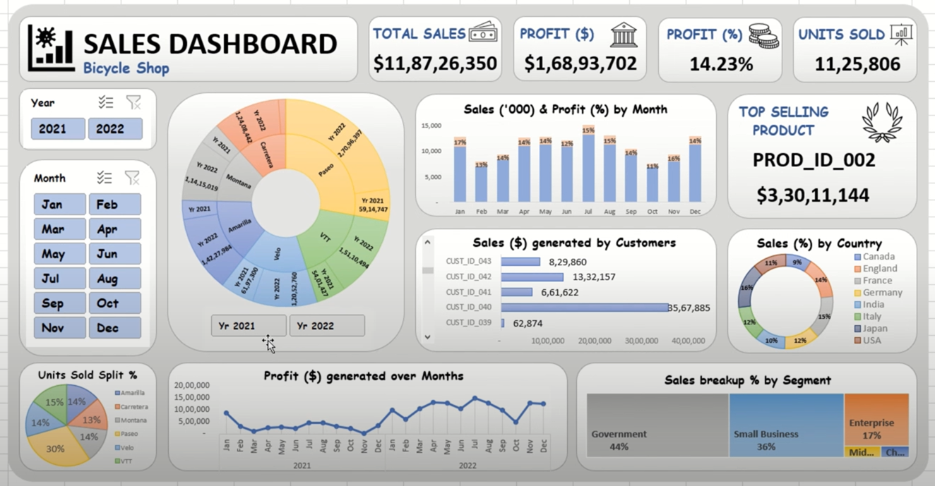

PIVOT TABLES:

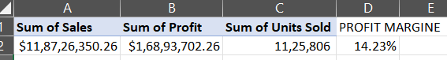

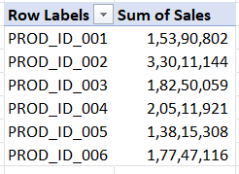
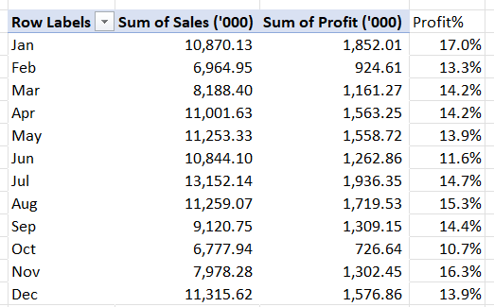

Future Scope
The Global Sales Performance Dashboard project offers a robust platform for analyzing bicycle sales data across multiple segments and regions. However, this Excel-based system holds great potential for future expansion and enhancement. With the integration of advanced features and modern technologies, the dashboard can evolve into a more powerful decision-support tool for business leaders, analysts, and marketers in the cycling industry.

- Advanced Predictive Analytics and Forecasting Models
Beyond Excel’s built-in forecasting tools, the project can incorporate predictive models such as Linear Regression, ARIMA, or even machine learning algorithms to forecast future sales, profit trends, and regional performance. This would allow businesses to anticipate demand cycles and optimize inventory and marketing strategies accordingly.
- Real-Time Data Integration
Linking the dashboard to real-time sales or CRM systems (via APIs or tools like Power Query) can enable instant updates and live tracking of KPIs. Real-time dashboards allow for proactive decision-making, quicker responses to market changes, and enhanced operational efficiency.
- Customer Behavior and Sentiment Insights
Incorporating customer reviews, surveys, or social media sentiment analysis can help the business understand public perception of bicycle products and brands. This qualitative data could be merged with sales performance metrics to guide product development and customer engagement strategies.
- Portfolio Management Features
The project can be extended to allow users to track and manage multiple stocks in a portfolio. Key metrics such as profit/loss, risk levels, diversification, and asset allocation can be calculated and visualized.
- Mobile and Web App Development
Turning this analysis tool into a user-friendly web or mobile app would make it more accessible. Interactive charts, voice assistants, and custom reports could enhance user engagement.

- Profitability Simulation and Scenario Analysis
By leveraging Excel’s Scenario Manager and Goal Seek, or integrating external tools, users can simulate the impact of changing pricing strategies, discounts, or marketing campaigns on overall profitability. This supports strategic planning and budgeting.

Reference
References
- Data.gov. (n.d.). Real Estate Sales 2001–2018 Dataset. Retrieved from: https://catalog.data.gov/dataset/real-estate-sales-2001-2018
- Investopedia. (n.d.). Profit Margin Definition. Retrieved from: https://www.investopedia.com/terms/p/profitmargin.asp
- Khan Academy. (n.d.). Intro to Data Analysis with Excel. Retrieved from: https://www.khanacademy.org/computing/computer-programming/sql
- Pandas Development Team. (2023). Pandas Documentation (for Data Preparation Reference). Retrieved from: https://pandas.pydata.org/
Links :
Linkedin : https://www.linkedin.com/in/yashreddy1154/
Github : https://github.com/yashreddy1154/excleproject
Source of Dataset : https://catalog.data.gov/dataset/real-estate-sales-2001-2018

Posts Screenshot:



